STAR TOPOLOGY
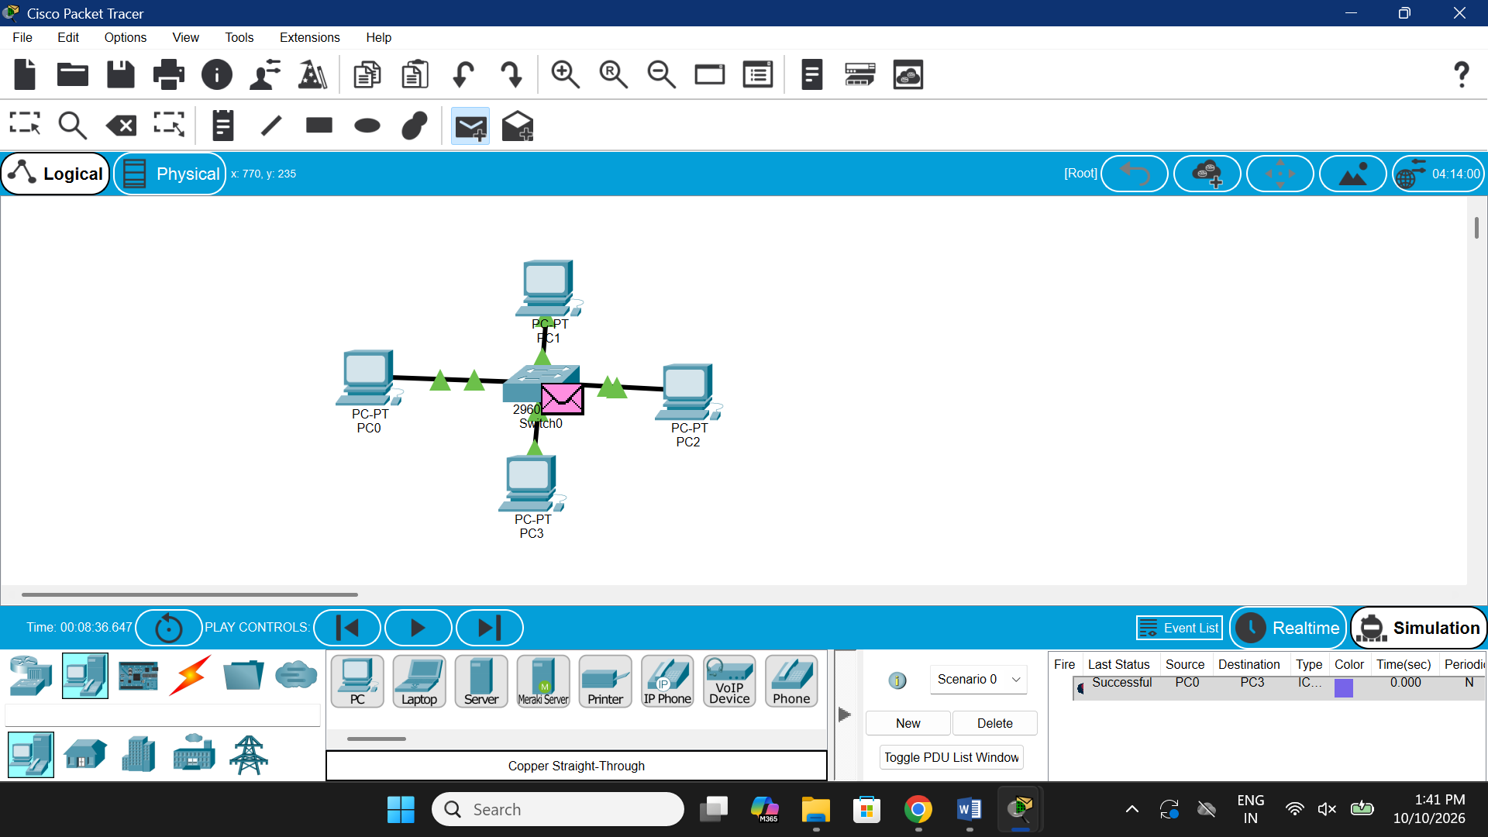

MESH TOPOLOGY

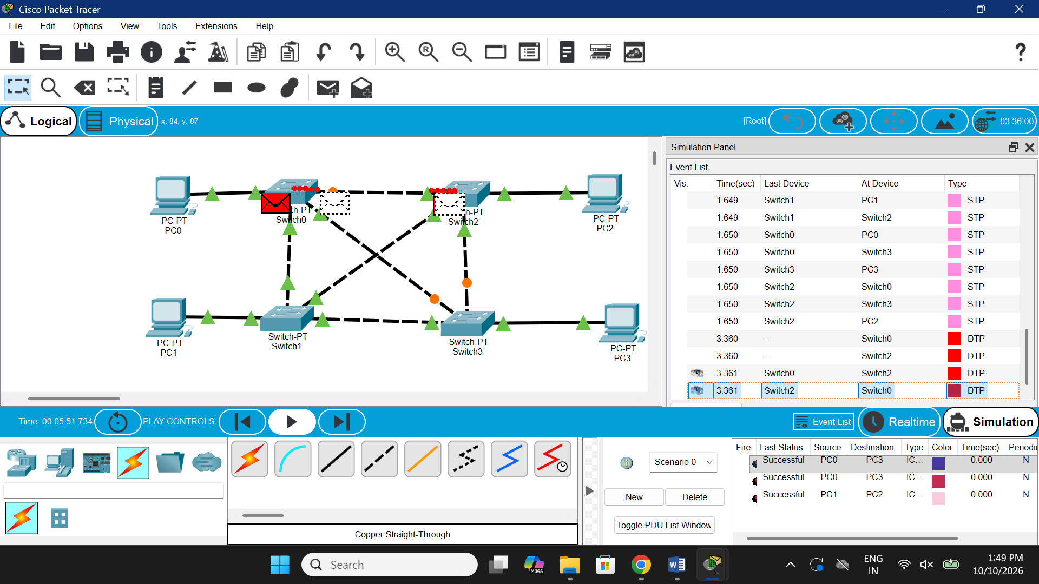

HYBRID TOPOLOGY

